**Create database ->tops_emp**

**Table name - > employee**

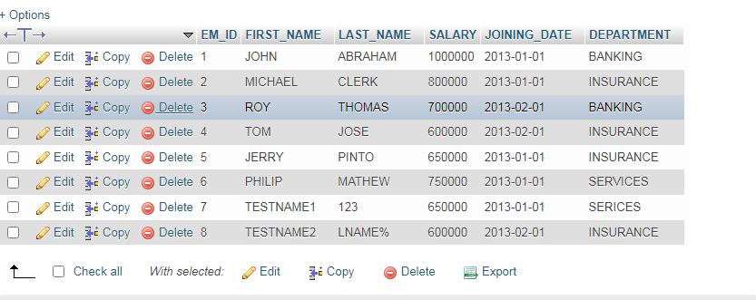

**Create database**

**Table name - > incentive**

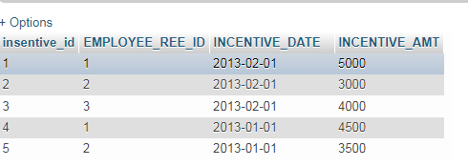

1. Get First_name from employee table using alias name “Employee Name”.

Ans=> SELECT FIRST_NAME "Employee Name" FROM employee ;

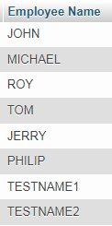

1. Get FIRST_NAME, Joining, Joining year, Joining Month and Joining Date form employee table.

Ans=> SELECT FIRST_NAME, DAY(JOINING_DATE) as "JOINING DATE",MONTH(JOINING_DATE) AS "JOINING MONTH", YEAR(JOINING_DATE) as "JOINING YEAR" FROM employee;

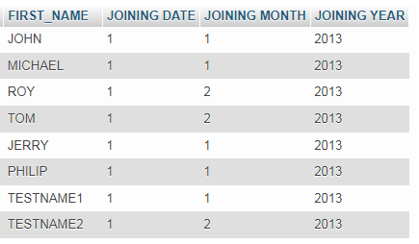

1. Get all employee details from the emplolee table order by First Name Ascending and Salary Descending?

Ans=> SELECT FIRST_NAME,SALARY FROM employee ORDER BY FIRST_NAME ASC,SALARY DESC;

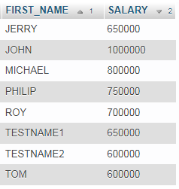

1. Get employee details from employee table whose first name contains ,,o”;

Ans=> SELECT * FROM employee WHERE FIRST_NAME LIKE '%o%';

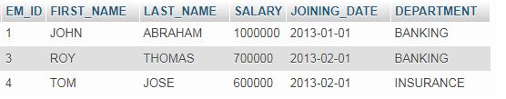

1. Get employee details from employee table ehose joining month is ‘’january’’.

Ans=> SELECT * FROM employee WHERE MONTHNAME(JOINING_DATE)='January';



1. Get department, total salary with respect to a department from employee table order by total salary descending.

Ans=> SELECT DEPARTMENT, sum(SALARY) as salary FROM employee GROUP BY DEPARTMENT ORDER BY SALARY desc;

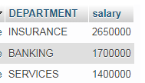

1. Get department wise maximum salary from employee table order by salary Ascending

Ans=> SELECT DEPARTMENT, MAX(SALARY) MAXSALARY FROM employee GROUP BY DEPARTMENT ORDER by SALARY ASC;

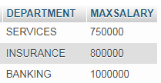

1. Select first_name ,incentive amount from employee and incentives table for those employee who have incentives and incentive amount greater than 3000.

Ans=>

SELECT FIRST_NAME FROM employee LEFT JOIN incentives ON employee.EM_ID=incentives.EMPLOYEE_REE_ID WHERE INCENTIVE_AMT>3000;

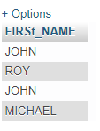

1. Select 2nd Highest salary form employee table.

Ans=> SELECT * FROM employee ORDER BY SALARY DESC LIMIT 1,1;



1. Select first_name , incentive amount from employee and incentives table for all employee who got incentive using left join.

Ans=>

SELECT EM_ID, FIRST_NAME, SALARY, JOINING_DATE, DEPARTMENT, INCENTIVE_AMT FROM employee LEFT JOIN incentives ON employee.EM_ID=incentives.EMPLOYEE_REE_ID WHERE INCENTIVE_AMT>0;

1. Create View of employee table in which store first name, last name and saraly only

Ans=> CREATE VIEW EMP_DATA AS SELECT FIRST_NAME,LAST_NAME,SALARY FROM employee;

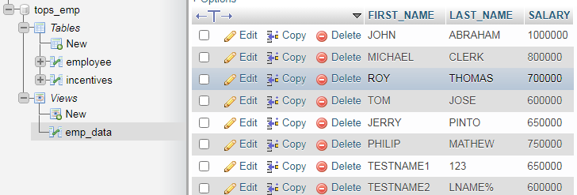

1. Create Procedure to find out department wise highest salary.

Ans=>

DELIMITER //

CREATE PROCEDURE HIGHEST_SALARY(IN DEPT VARCHAR(255))

BEGIN

SELECT DEPARTMENT,MAX(SALARY)

FROM employee

WHERE DEPARTMENT = DEPT GROUP BY DEPARTMENT;

END //

DELIMITER ;

1. Create After Insert trigger on employee table which insert records in view table.

Ans=>

DELIMITER//

CREATE TRIGGER AFTER_INSERT_RECORD AFTER INSERT ON employee FOR emp_data;

BEGIN

INSERT INTO emp_data SET ACTION='INCERT' FIRST_NAME='HITESH',LAST_NAME='JOSHI' SALARY='100000';

END//

DELIMITER ;